Modelling and the Dynamics of Infectious Diseases

Practical 1: Network modelling
Practical

Objectives:

By the end of this session you should
- understand basic network properties
- appreciate that both local and global properties influence network structure
- understand how differences in network structure can influence infection transmission
Introduction

This practical is largely based on Watts & Strogatz 1998 Nature paper on the dynamics of “small world” networks. This paper is provided for your information.

In this paper, different types of networks are considered:
- An ordered network
- An intermediate network – ordered but with some random connections (“small world”)
- A random network

This practical consists of two parts, in the first we consider some of the structural properties using examples of the three types of networks, in the second section we look in more detail at the effect differences in network structure have on the transmission dynamics of an infection. We will consider the effect of network structure on LOCAL spread (here we consider local to be spatially close i.e. 1 to 2) and GLOBAL spread (across the whole network)

Network 1 – A regular or ordered network

An ordered network was created by considering a group of individuals (nodes or vertices), positioned around the edge of a diamond shape. Connections (edges) between them are formed such that each person is connected to their 4 nearest neighbours, resulting in a regular network shown in Figure 1. A diagram of a network such as this is called a graph.
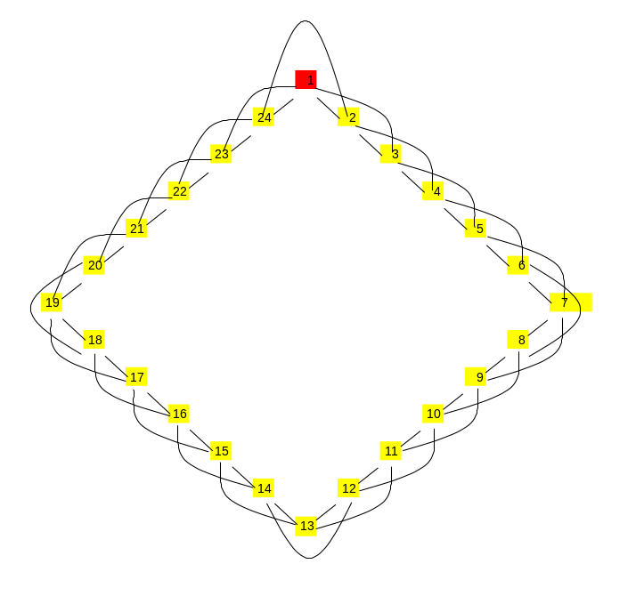
Figure 1 Network 1 – A Regular or Ordered network
Network 2 – An ordered network with some random rewiring

Beginning with the ordered network in Figure 1, each edge has a probability of being broken and reconnected to a different individual, chosen at random from the rest of the population. Using a small probability of 7%, 4 edges (out of 48) were rewired. This resulted in the network shown in Figure 2.

The number of individuals and the number of connections is the same in Network 1 and Network 2.

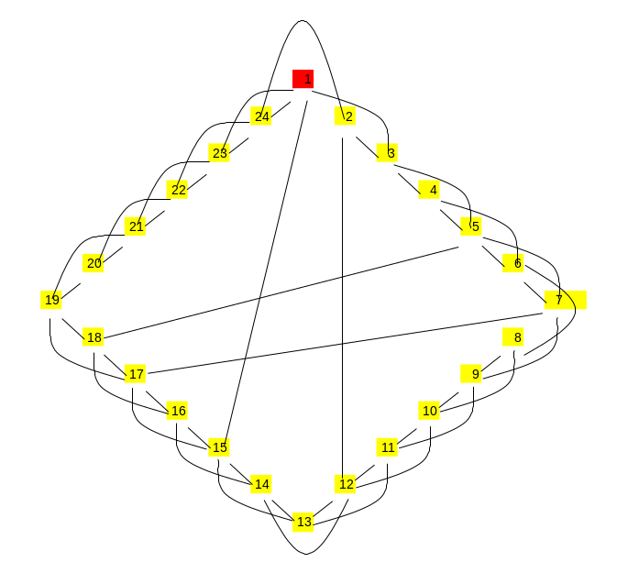
Figure 2 Network 2 – An ordered network with some random rewiring
Network 3 – A Random network

A random network is created by increasing the probability of an existing connection breaking and reforming to 1, i.e. all of the connections are formed at random. The total number of individuals in the network is 24 and the total number of edges is 48 as in Networks 1 and 2. An example random network produced in this way is shown in Figure 3.

Figure 3 Network 3 - A Random network
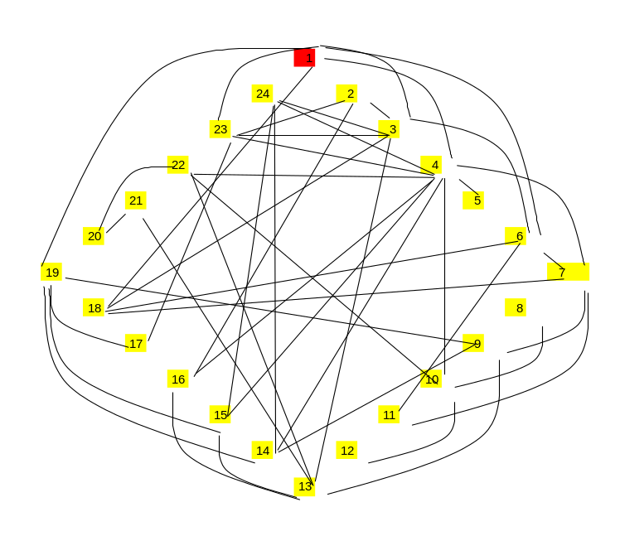

The three networks all have 24 individuals (nodes), with 48 connections (edges). A network may be used to represent different sorts of contacts or units. In this practical we consider individuals and their sexual contacts and transmission of an STI. Other possible networks could be family contacts, contacts between animals on different farms or telephone lines.

The properties of the three networks will be explored in more detail in this practical.

Part 1 – Basic properties of networks

1. Open the spreadsheet “Network Practical 1.xls”
Click “Enable Macros”

EXCEL NOTES are provided as an appendix to help you complete the practical efficiently and provide extra info about excel techniques.

EXCEL NOTE 1 – What to do if you can’t run the macros.

There are 5 worksheets in the spreadsheet, Network 1, Network 2, Network 3, Model parameters and Results.

Contents of network worksheets
In worksheet Network 1, you will see a diagram of Network 1 (Figure 1).

Columns AG-AM show a table called Infection Status, including current infection status (AH, Current, green, 1 = infected, 0 = susceptible) , infection status in next generation (AI, Next, blue), transmission probability (AJ), number of infected (AK) and uninfected partners (AL) and the total number of partners (AM).
Columns AO-AX show the infection status of each partner.

NOTE: Columns AG-AX will be explained in more detail in the second part of the practical.

Columns AZ-BI show the identity of each partner
Columns BK-CI show a contact matrix corresponding to network 1.
The total number of partners per person is shown in column CO (blue)

Convince yourself that the information in the network diagram, columns AZ-BI and BK-CI are different ways of representing the same information.

Worksheets Network 2 and Network 3 follow the same format

- Preliminary exercise
Press the button “Update” a few times. You should see infection (red) passing around the network. Look at how the numbers in columns AH (current infection status) and AI (infection status in the next timestep) change and how this corresponds to the colours on the figure

EXCEL NOTE 2 – Conditional formatting of cells

The next section will take you through some calculations of a variety of network properties for networks 1,2 and 3. The following table is provided for your answers to the questions that follow.

 | Network 1 | Network 2 | Network 3
Total individuals | 24 | 24 | 24
Total partnerships | 48 | 48 | 48
Mean partners per person | 4 | 4 | 4
Variance in number of partners per person | 0 | 0.35 | 4.52
Characteristic path length between 1 and 13 | 6 | 2 | 2
Clustering coefficient – person 1  (see below for calculation) | 0.5 | 0.16 | 0.33

Q1. Fill in the first 2 rows of the table (remember there are 2 people per partnership)

Q2.
a) Calculate the mean and variance in the number of partners per person in Network 1, using the information in column CO (blue).

EXCEL NOTE 3 – Excel functions for mean and variance

b). Repeat Q1 for network 2 and network 3
Two measures of the network structure are defined in Watts and Strogatz. The first is the characteristic path length (L) which is the number of edges (links) in the shortest path between one person and another.

Q3. What is the characteristic path length between person 1 and person 13 in

- Network 1?

- Network 2?

- Network 3?

The second measure is the clustering coefficient.

Q4. Consider individual 1 in network 1, who has 4 contacts with individuals 2,3, 23 and 24.
The following table is provided for you to help answer the following questions

 | 1 | 2 | 3 | 23 | 24
1
2 | *
3 | * | *
23 | *
24 | * | * |  | *
The red stars are the connections that exist in this network. This table is like the table in columns BK onwards of the Excel spreadsheet. You start with person 1 and put a marker in for each of their connections. Then you move to person 2 and you mark all the connections of 2 which have not already been put in the table (which is why in the column for 2 you can’t put any connections in for connections to 1, it’s blacked out). Then you move to person 3 and mark in all the new connections. The total number of connections in the network is the number of stars in this table (or 1s in the Excel spreadsheet). This is how you can calculate the answer to Q1 above – sum of BK29 to CI29.

a) How many of the contacts of person 24 are also contacts of person 1? Person 24 partners: 1,2,23; Person 1 partners:2,3,23,24. 2 are shared

b) Given that individual 24 has 4 contacts, what is the maximum number of contacts 24 can have who are also contacts of individual 1? (excluding the contact 24-1)
3 (all the other contacts)

c) Repeat a) and b) for individuals 2,3 and 23.Person 2: 2; Person 3: 1; Person 23: 1

d) Calculate the maximum number of contacts of contacts of 1 (i.e. contacts of 2,3, 23 and 24) that are also contacts of 1. (If all blanks in table were contacts)
6 – in the table, black stars are the contacts of 1. The rest of the empty boxes are the potential contacts of contacts of 1 which are also contacts of 1. There are 6 of these.

e) Calculate the number of partnerships which exist in this subsection of contacts of contacts of 1 within network 1
Within subnetwork: 3

f) Calculate the proportion of potential partnerships which exist (i.e. answer to (e) / answer to (d) )
Within subnetwork: 3
Potentially could have been: 6
What proportion of potential partnerships = 3/6 = 50%

You have just calculated the clustering coefficient for person 1. This is defined as the proportion of an individual’s contacts that are contacts with each other. Formally, for a vertex (node) v with k contacts, at most k(k-1)/2 edges can exist between them i.e. every contact is connected with every other contact or “all my friends are friends with each other”. The clustering coefficient is the fraction of these allowable edges, which actually exist. The network clustering coefficient is the average across all the individuals in the network

e) Convince yourself that this is what you have just calculated for person 1.
f) Calculate the clustering coefficient for person 1 in Network 2 and 3.
Network 2
 | 1 | 3 | 15 | 23 | 24
1
3 | *
15 | *
23 | *
24 | * |  |  | *

Local clustering coeffient = 1/6 = 0.16 (1 red star, 6 potential boxes)

Network 3
 | 1 | 3 | 4 | 6 | 18 | 19 | 23
1
3 | *
4 | *
6 | * | *
18 | * | * |  | *
19 | *
23 | * | * | *

Local clustering coefficient = 5/15 =1/3 = 0.33

Q5. Complete the table (before Q1) with your answers to Q1-4. Remember, each partnership involves 2 people.

Q6. Which type of network do you predict will allow infection to spread fastest?
a) locally? (i.e. between adjacent numbers e.g. person 1 and 2)

Network 1 or 2

b) globally? (i.e. between any two people e.g. 1 and 13)

Network 3 because no local saturation
Part II – The effect of network structure on the transmission dynamics of an infection

Return to Column A in worksheet “Network 1”.

In the second part of the practical we will consider a model of infection transmission in the 3 different networks.

Model description

Infection is transmitted only between an infected individual and a susceptible contact. When a susceptible becomes infected, the cell turns red.
When an infected individual recovers, they return to being susceptible (to yellow).
The infection and recovery processes occur stochastically

Q7 Define the type of model described (SIS, SIRS, SEIRS etc, stochastic/deterministic)
SIS

Connections between individuals remain constant throughout the simulations i.e. it is a static network.

Q8. How appropriate is a static network for a model of STI transmission? (e.g. consider duration of sexual partnerships and the likely duration of an STI)
It depends what timescale you’re looking at. If you’re looking at a short time outbreak, then maybe people’s partnerships are steady. For a slower epidemic less appropriate. It therefore depends on the characteristics of the epidemic – duration of infection compared to durations of partnerships. It also depends on the behaviour of the population. People may have on average 4 partners in their lifetime, but perhaps not all at once. A static model suggests that 1 person is having constant sexual partners at once.

Model details

The infection parameters are defined in the worksheet Model Parameters and used in the network worksheets.

The probability of recovery is set at 0.2 per generation.
The probability of transmission is also set at 0.2 per generation.

Please don’t change these values when doing the practical questions, so that the results are comparable across the class. If you wish to vary the model parameters for your own interest or to attempt the supplementary questions, you only need to change the values in the “Model parameters” worksheet and the values in the network sheets will be updated.

The probability that a susceptible will be infected in a generation depends on how many infected partners they have. This can be calculated from the Reed-Frost formula:

Probability of being infected = 1 – (1-p)^{n}

where p is the probability of transmission in one generation from an infected to a susceptible and n is the number of infected partners.
Probability any one of your neighbours don’t infect you: 1-p
Probability that none of your neighbours infect you: (1-p)^{n}
Probability you DO get infected by at least one of them is 1-(probability you don’t get infected by any of them) = 1-(1-p)^{n}

The transmission probability is calculated using this formula in Column AJ.

AK uses countif to count the number of infected partners (n) (Columns AO-AX)
Columns AO-AX store the current infection status of partners of an individual. The Vlookup function (Vertical array lookup) is used to locate the corresponding partner number (1-24, from columns AZ-BI), lookup that number in column AG, then show the current infection status value from AH.
If you click on a cell in column AO, then click in the formula in the formula bar at the top of the screen the relevant cells will be highlighted.

Infection status

Whether recovery or transmission occurs in a given generation is determined in the “Next” column (AI), using the following if statement:

=IF(AH5=1,IF(RAND()<$AK$33,0,1),IF(AH5=0, IF(RAND()<AJ5,1,0),0))

RECOVERY - If (individual 1 is currently infected (if(AH5 = 1), then choose a random number between 0 and 1, if that is less than the probability of recovering, change to 0 (recover), otherwise stay infected).
TRANSMISSION - If individual 1 is currently uninfected (if(Ah5=0), then choose a random number, if that is less that the probability of transmission (calculated in AJ5, using reed frost), then transmission occurs (change to 1), otherwise stay uninfected (stays 0).

Running the model

To start the model, press RESET. This seeds infection in person 1 and sets everyone else to the susceptible state and sets the generation counter to 0.
To run the model, press the UPDATE button on the worksheet. This runs a macro, which copies the Column AI (“Next”) into the “Current” generation (AH) and also updates the generations counter.
To run another simulation, press RESET, then UPDATE as before.
Spend a few moments familiarising yourself with the model in each of the different networks.

EXCEL NOTE 4 – making macros in excel is easy!

Analysis of the epidemiology of infection in different networks

We will now investigate infection transmission dynamics in the different networks in a more quantitative way. Person 13 is the furthest away (in space) from the initial infected individual in the network, so we will consider how fast the infection spreads with reference to person 13.

As the model is stochastic, we need to perform repeated runs to evaluate the outcomes.

Q9. Run the model until infection dies out or person 13 becomes infected, record when this occurs. Repeat 10 times (or collaborate!) See below

Fill in your results in the table below – If it fades out before it gets to 13, put the number in the second column, if it gets to 13 then record the generation when it gets to 13.

Q10. Repeat Q9 for Networks 2 and Network 3 See below

Q11
a) For Network 1,2 and 3, calculate the average time to infection for person 13 (if there no fade-out). See below. Note that it is longest for the network with the longest path length from 1 to 13.

b) Can you predict (given your answer to question 6) in which network person 24 will be infected fastest (i.e. local spread) You can test your prediction in your spare time. See table in part 1. Local clustering round person 1 (the first infected person in the population) is highest in Network 1 so we would predict Network 1.

- Is a network 2 more like an ordered (network 1) or a random (network 3) network with respect to global and local spread?
It seems to be more like network 2. The few ‘small world’ connections make a big difference to the time to travel through the network.

 | Network 1 (Ordered) |  | Network 2 (some rewiring of ordered network) |  | Network 3 (random)
Simulation | Generation infected | Fade-out generation | Generation infected | Fade-out? | Generation infected | Fade-out?
1 | 14 |  | 8 |  |  | 1
2 |  | 9 | 9 |  | 8
3 | 20 |  |  | 6 | 8
4 | 23 |  |  | 2 | 6
5 | 25 |  | 7 |  | 3
6 | 11 |  | 16 |  | 6
7 | 27 |  | 4 |  | 2
8 | 30 |  | 28 |  | 5
9 | 16 |  | 15 |  | 8
10 | 14 |  | 7 |  | 5

- Average: Network 1: 20, Network 2:11.75, Network 3:5.6
Fade out probability: Network 1: 0.1, Network 2:0.2, Network 3: 0.1
Another feature of epidemiological interest is the extent of clustering of cases in an epidemic. We consider two individuals to be adjacent if they are located next to each other in the diagram (i.e. any two consecutive numbers, plus 24 and 1 are adjacent pairs). A cluster is defined as the number of cases in adjacent individuals.

Q12 Run the model for 5 generations, repeat 4 times for each network. Complete the following table describing the clustering of cases in the epidemic.
a) Which network has the largest clusters, and which the smallest?
Very different between the different simulations in the class – 4 is too small a sample. You might expect network 2.
b) For each run, calculate the proportion of single cases.

NETWORK 1 | Cluster size |  |  |  | TOTAL CASES | Proportion of cases which are singles
Simulation | 1 | 2 | 3-4 | 5+
EXAMPLE | 2 | 1 | 0 | 0 | 4 | 2/4
1 | 3 |  |  |  | 3 | 1
2 | 3 |  |  |  | 3 | 1
3 |  |  | 2 |  | 7 | 0
4 | 1 |  | 1 | 1 | 10 | 1/10

NETWORK 2 | Cluster size |  |  |  | TOTAL CASES | Proportion of cases which are singles
Simulation | 1 | 2 | 3-4 | 5+
1 |  |  |  | 1 | 5 | 0
2 |  |  |  | 1 | 7 | 0
3 | 3 |  |  |  | 3 | 1
4 |  | 2 |  |  | 4 | 0

NETWORK 3 | Cluster size |  |  |  | TOTAL CASES | Proportion of cases which are singles
Simulation | 1 | 2 | 3-4 | 5+
1 | 5 |  | 3 |  | 8 | 5/8
2 | 1 | 3 | 1 |  | 10 | 1/10
3 | 4 | 2 | 1 |  | 11 | 4/11
4 | 1 | 1 | 2 | 1 | 19 | 1/19

Q13. What other features would you like to add if you wanted to build a more realistic model of the transmission of a sexually transmitted infection?
Dynamic network, People entering and leaving the population, Symptoms leading to abstinence/treatment

References
D. J. Watts and S. H. Strogatz. Collective dynamics of 'small-world' networks. Nature 393 (6684):440-442, 1998.
RM Anderson and RA May. Infectious Diseases of Humans. 1991.

Supplementary questions

S1. Calculate effective contact rate for each network?

Effective contact = mean partners + variance in partners/mean

c=m+δ²/m

You should be familiar with this formula from previous lectures (Anderson & May 1991)

S2. Calculate the R₀ of this infection in Network 1, 2 and 3
R₀ = βcD

NB remember that the average duration of infectiousness = 1/recovery rate
You can calculate c from the first table in the answers.
Network 3 has the largest variance, so the largest c so the largest R0. Which reflects what we saw in the answers above

Consider the same population (i.e. 24 individuals) but where the contacts are unknown, i.e. there is no network information, but the transmission probability, duration of infection and average number of contacts per person are known.

S3. Can you estimate the probability of person 13 being infected in the first generation? (Hint: make a simplifying assumption about mixing)
Probability of transmission per contact * Probability that 13 is a contact of person 1
0.2 * 4/23 = 0.035
(23 possible contacts, 4 actual contacts, what’s the probability that 13 is one of them)

S4. How does this compare with the probability of infecting 13 in networks 1, 2 and 3?
- Probability of fading out before getting to 13
In the networks, 80% of time it got 13, but after multiple generations.
Path length to 13 is greater than 1 in all of these networks, so probability of 13 being infected in the first generation is 0.
S5. Consider what would happen if you change the model parameters. E.g. can you predict values of beta and D which would result in faster spread or higher prevalence? Can you think of some other network characteristics, which you could investigate with this framework, e.g. proportion of realisations where extinction or fade-out occurs?
You can investigate what happens to the speed of spread and probability of extinction/fade-out with different parameter values by changing them in the model parameter worksheet.
EXCEL NOTES

EXCEL NOTE 1 – If you can’t run the macros. Your machine may not be set up to run macros automatically. To change the settings in Excel do the following:
Open Excel
Go to Tools/Macros/Security
Select Medium security
Close Excel and any open files
Reopen file “Network Practical 1.xls” and Click “enable macros”

EXCEL NOTE 2 – Conditional formatting of cells
This is done using conditional formatting. Select one of the coloured cells (representing an individual), go to Format/Conditional Formatting you will see how the colour of the cell depends on the value in the corresponding cell in column AH.

EXCEL NOTE 3 – Excel functions for average and variance
The excel function to calculate the mean is AVERAGE(cell:cell). The function for variance is VAR(cell:cell)

EXCEL NOTE 4 – making macros in excel is easy!
Go to Tools/Macro/Record New Macro
(You might need to press a button “record” which will appear on the screen)
Do the action you want the macro to do (e.g. select a set of cells and copy to a new location), then press the stop button (▀). To run the macro you have just recorded go to Tools/Macro/Macros (►). There are also options to create a button which appears in your spreadsheet. You can also view the visual basic code produced automatically from your actions in excel. Go to Tools/Macro/Macros there should be one called Update. Select this and go to Edit. PLEASE DO NOT MAKE ANY CHANGES! Just view the code if you are interested.

DH from here

http://www.telegraph.co.uk/technology/facebook/8704891/Six-degrees-of-separation-theory-tested-on-Facebook.html

https://www.nature.com/articles/30918.pdf

http://worrydream.com/ScientificCommunicationAsSequentialArt/ScientificCommunicationAsSequentialArt.pdf

Supplement 1: Clustering

Just like “degree” and “mean degree”, clustering can be measured at individual level (local clustering coefficient) and at network level (global clustering coefficient).

We can think of local clustering as follows: if all of my friends are also friends with each other, I have clustering coefficient 1, the maximum possible value. If none of my friends know each other, then I have clustering coefficient 0, the minimum possible value.

Local clustering is defined as the number of links between neighbours of a node that are present in the network, as a fraction of the number of nodes that could exist.

- If node j has n neighbours, then there are n(n-1)/2 possible links between them – why?

The mean value of local clustering on a network is known as the “network average clustering coefficient.” It is NOT the same as the global clustering coefficient, which is defined as:

(3 x total number of triangles)/(total number of connected triples)

- Why is this not (always) the same as the network average clustering coefficient?
- Can you explain the factor of 3?
- Which clustering measure is used by Watts and Strogatz?

One for the mathematicians:

If A is the adjacency matrix of a (simple, undirected) graph G, then the degree distribution of G is given by the row sums of A.

- A^2_{ij}=1 if node j can be reached from node i in exactly 2 steps
- A^3_{ij}=1 … 3 steps
- Etc. (but we don’t need any more)

If ||A|| denotes the sum of all entries in A, and tr(A) is the sum of all diagonal elements, then:

- ||A^3|| id the number of triangles in G
- ||A^2||-tr(A^2) is the number of connected triples – why?
- Can you think of a way to generalise the definition of clustering beyond immediate neighbours?

Further reading:
- http://rsif.royalsocietypublishing.org/content/2/4/295.short
- More?

